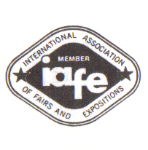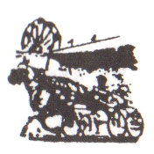
Hemlock Lake
Union Agricultural Society

“The Little World’s Fair”
“The Largest Fair in Livingston County”

CONCESSION/VENDOR
RULES AND REGULATIONS ACKNOWLEDGEMENT

To be considered for a Vendor position, this document must be signed and returned with your contract.

By signing below, I agree to the following:

I have received a copy of the Concession/Vendor rules and regulations authored by the Hemlock Lake Union Agricultural Society

I have read and understand these rules and regulations.

I will comply with all the Rules and Regulations set forth by said document.

Company / Business Name:

Lessee Printed Name:

Lessee Signature:

Date:

Send all correspondences to:
Mary Jo Strong
Attention Vendor Coordinator
7437 Groveland Hill Rd
Groveland NY 14462

